Chemistry Name: ________________
2019 Trial exam

SECTION A – Multiple-choice questions

Instructions for Section A
Answer all questions.
Choose the response that is correct or best answers the question.
A correct answer scores 1, an incorrect answer scores 0.
No mark will be given if more than one answer is completed for any question.
Marks will not be deducted for incorrect answers.

Use the following information to answer Questions 1 and 2
The Australian Department of Environment and Energy monitors Australia’s energy consumption. The table below summarises the main energy sources for the years 2015-16.
(1 PJ = 10¹⁵ Joule)
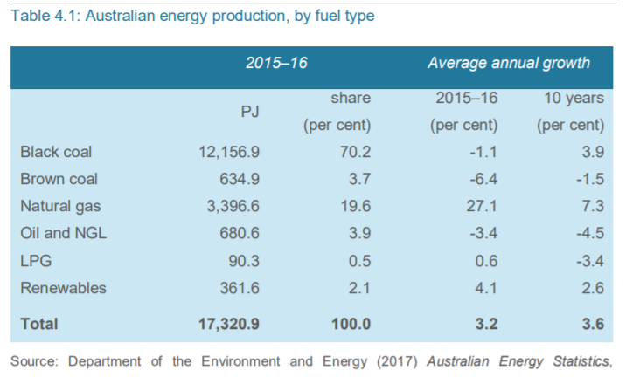

Question 1
The percentage of our energy sourced from fossil fuels in 2015-2016 was
A. 73.9
B. 77.8
C. 93.5
D. 97.9

Question 2
The mass of methane that would need to undergo complete combustion to produce the energy provided by natural gas would be, in kg,
A. 3.8 × 10⁹
B. 6.1 × 10¹⁰
C. 3.8 × 10¹²
D. 6.1 × 10¹³

Question 3
The complete combustion of 3 mole of an alkane produces 149 L of CO₂ at SLC. The alkane is
A. methane
B. ethane
C. butane
D. octane

Question 4
The main form of chemical bonding within biodiesel molecules is
A. dispersion forces.
B. hydrogen bonding.
C. dipole bonding.
D. covalent bonding.

Question 5
Molasses is a by-product of the sugar industry. It contains a mixture of saccharide molecules. Scientists have designed a process that enables them to produce a biofuel from molasses. The biofuel is most likely to be
A. natural gas
B. biogas
C. bioethanol
D. biodiesel.

Use the following information to answer Questions 6 to 8
The diagram below shows a zinc-mercury oxide button cell. This is a primary cell that produces a voltage of 1.35 volts. These cells were used extensively but have been phased out in recent years.
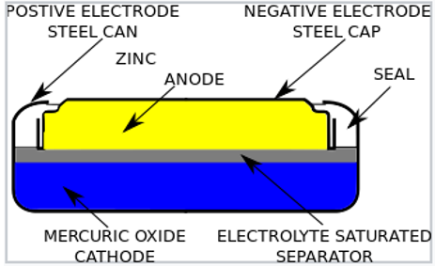

The half-equation for the reaction involving mercury in this cell is

HgO(s) + H₂O(l) + 2e⁻ Hg(s) + 2OH⁻(aq)

Question 6
The likely half-equation for the anode reaction is
A. Zn(s) + 2OH⁻(aq) Zn(OH)₂(s) + 2e
B. Zn(s) + H₂O(l) Zn(OH)₂(s) + OH⁻(aq) + e⁻
C. Zn(OH)₂(s) + H₂O(l) + 2e⁻ Zn(s) + 2OH⁻(aq)
D. Zn(s) + 2OH⁻(aq) + 2e⁻ Zn(OH)₂(aq) + H₂O(l)
Question 7
In this cell, the
A. pH will rise during discharge due to the production of OH⁻ ions.
B. pH will fall during discharge due to the production of OH⁻ ions.
C. mass of the cell will drop during discharge as zinc metal reacts.
D. mass and the pH will remain constant.

Question 8
This cell has been phased out in recent years. A likely reason for its demise is
A. the issues with its safe disposal.
B. there is little market for button batteries.
C. that all small batteries are now recyclable.
D. that zinc is now a very scarce material.

Question 9
Sulfate ions can be converted to peroxysulfate ions (S₂O₈²⁻)in a redox reaction. A balanced half equation for this reaction is
A. 2SO₄²⁻(aq) S₂O₈²⁻(aq) + 2e⁻
B. SO₄²⁻(aq) + 4H₂O(l) S₂O₈²⁻(aq) + 8H⁺(aq) + 2e⁻
C. 2SO₄²⁻(aq) + 4H₂O(l) 2S₂O₈²⁻(aq) + 8H⁺(aq) + 2e⁻
D. 2SO₄²⁻(aq) + 2e⁻ 2S₂O₈²⁻(aq)

Question 10
An energy profile diagram below shows the energy changes occurring when methane undergoes complete combustion.
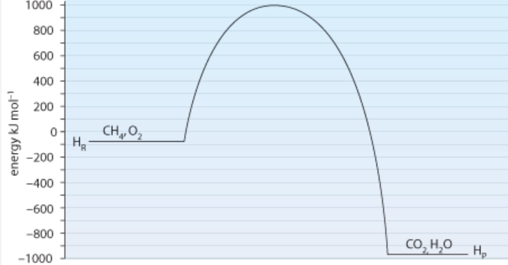

The activation energy and the enthalphy change for the reverse reaction will be, respectively,
A. -1090 kJ mol⁻¹ and -890 kJ mol⁻¹
B. +1090 kJ mol⁻¹ and +890 kJ mol⁻¹
C. +1980 kJ mol⁻¹ and +890 kJ mol⁻¹
D. +1980 kJ mol⁻¹ and -890 kJ mol⁻¹

Question 11
The decomposition of hydrogen iodide gas is a reversible reaction.

2HI(g) ⇌ H₂(g) + I₂(g)

3.0 mol of HI is added to an empty 2.0 L reactor and given time to reach equilibrium. The amount of H₂ gas at equilibrium is 0.20 mol. The value of the equilibrium constant at this temperature is
A. 0.0059
B. 2.0
C. 65
D. 169

Use the following information to answer Questions 12 and 13
The reaction between Fe³⁺ and SCN⁻ ions forms a complex with a deep red colour. The equation for this reaction is

Fe³⁺(aq) + SCN⁻(aq) ⇌ FeSCN²⁺(aq)
deep red

Question 12
Which of the following changes will not lead to an increase in the intensity of the red colour?
A. Evaporation of some water from the solution.
B. Addition of a few drops of KSCN solution.
C. Addition of a few drops of Fe(NO₃)₃ solution.
D. Dilution with water.

Question 13
A few drops of AgNO₃ is added to an equilibrium mixture of the above chemicals. The Ag⁺ ions form an AgSCN precipitate. As a result of this addition, the
A. value of the equilibrium constant increases as the reverse reaction is favoured.
B. concentration of SCN⁻ ions in the mixture will be lower than it was before the addition.
C. concentration of FeSCN²⁺ will increase as the forward reaction is favoured.
D. concentration of SCN⁻ ions in the mixture will be higher than it was before the addition.

Use the following information to answer Questions 14 and 15
An electrolytic cell is shown below that produces chlorine gas and hydrogen gas.

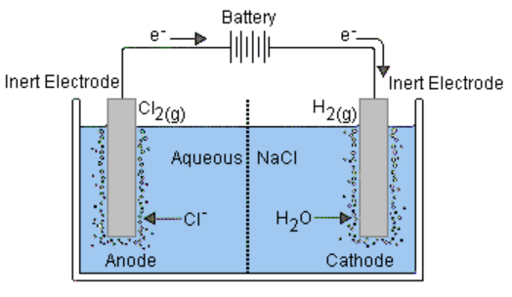

Question 14
The electrolyte in this cell is likely to be
A. 0.1 M HCl
B. 0.1 M NaCl
C. 4.0 M NaCl
D. NaCl(l)

Question 15
The cell runs with a current of 2.80 amps and a voltage of 5.20 V for 5.00 minutes. The volume of gas produced at the cathode at SLC in this time will be, in L,
A. 0.054
B. 0.108
C. 0.216
D. 108

Question 16
What is the systematic name of this molecule?
A. 3,4-dibromo-2,5-dimethylheptane
B. 3,4-dibromononane
C. 4,5-dibromo-3,6-dimethylheptane
D. 3,6-dimethyl-4,5-dibromoheptane

Question 17
Pentan-1-amine could be formed from the reaction of
A. pentane and ammonia.
B. 1-chloropentane and ammonia.
C. butan-1-ol and chloromethane.
D. pentanoic acid and ammonia.

Question 18
A substance with molecular formula C₄H₆Cl₂ could have
A. no isomers of any type.
B. geometric isomers only.
C. geometric or structural isomers only.
D. structural isomers, geometric isomers or optical isomers.

Question 19
A HPLC printout for a substance is shown below. A polar stationary phase has been used.
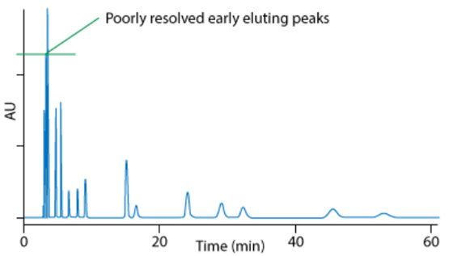
The chromatogram indicates that
A. the substance being tested has few impurities.
B. there is likely to be significant concentrations of polar components in the mixture.
C. there is likely to be significant concentrations of non-polar components in the mixture.
D. the column is not providing adequate separation of peaks.

Question 20
Butan-2-ol is tested in both proton-NMR and carbon-NMR. It will have

 | Hydrogen environments | Carbon environments
A. | 3 | 3
B. | 4 | 3
C. | 5 | 3
D. | 5 | 4

Question 21
A carbon-NMR is shown below.
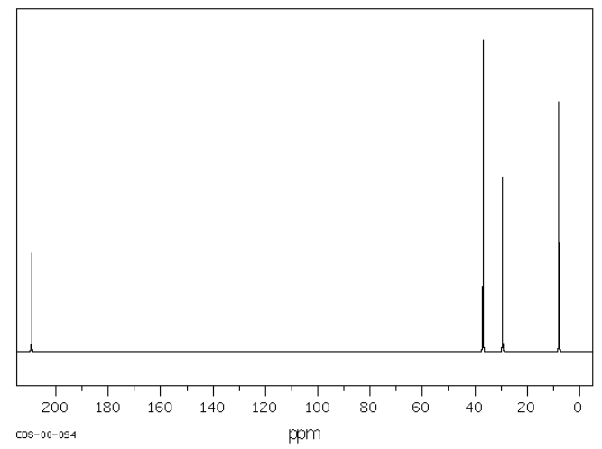
This molecule is likely to be
A. butane
B. butan-1-ol
C. pentanoic acid
D. butanone
Question 22
An impure sample of oxalic acid (M = 90 g mol⁻¹) is tested through titration. A 3.00 g sample is dissolved in water. 29.4 mL of 0.25 M NaOH is required to neutralise the diprotic oxalic acid. The acid concentration, as a %m/m, is closest to
A. 5.5
B. 11
C. 22
D. 55

Question 23
The mass spectrum of a molecule is shown below.
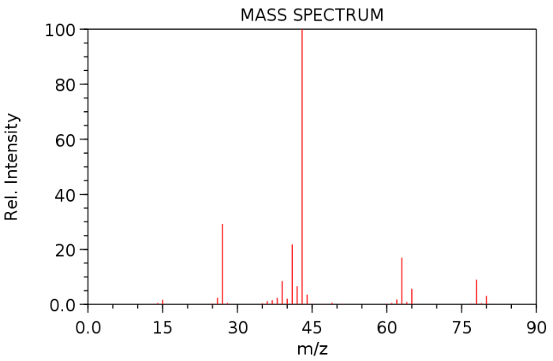
The molecule is likely to be
A. 2-chloropropane
B. propan-1-amine
C. pentane
D. propanoic acid

Question 24
Ethanoic acid can be formed from the oxidation of ethanol. The same reaction can be performed as a titration which can be used to determine the ethanol concentration. Dichromate ions (Cr₂O₇²⁻) are often used for the oxidation. The dichromate ions are converted in acid conditions to Cr³⁺ ions.
In this titration the mole ratio of ethanol to dichromate ions will be
A. 1:1
B. 2:3
C. 3:2
D. 5:1

Question 25
Which of the following food molecules contains the highest number of hydroxyl functional groups?
A. glucose
B. glycine
C. glycerol
D. glycogen

Question 26
A particular fatty acid has a molecular formula of C₂₀H₃₂O₂.
How many carbon-to-carbon double bonds does this molecule contain?
A. 1
B. 2
C. 3
D. 4

Question 27
The effectiveness of three different enzymes at different pH levels is illustrated in the graph below. All three enzymes play an important role in human digestion.
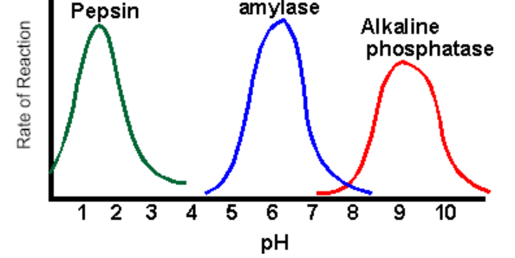
From the graph it is likely that
A. amylase is in saliva, pepsin in the stomach and phosphatase in the small intestine.
B. amylase and pepsin are found mainly in saliva and phosphatase in the stomach.
C. amylase is in saliva, pepsin in the small intestine and phosphatase in the stomach.
D. all three enzymes will operate mainly in the stomach.

Question 28
The molecule 2-amino-3-hydroxypropanoic acid is also known as
A. glycine.
B. serine.
C. threonine.
D. valine.

Question 29
A 5.0 g sample of carbohydrate is used to heat a sample of water from 17.5⁰C to 25.5⁰C. The same mass of fat should be able to increase the temperature of the same water sample by
A. 8⁰C
B. 16⁰C
C. 18.5⁰C
D. 20.8⁰C

Question 30
A student conducts a titration adding acid into a burette that was not cleaned at all after the previous experiment. She is using a standard acid solution to determine the concentration of a alkaline solution. In the previous experiment a base had been used in the burette. The impact of this poor technique is likely to be a
A. higher titre than expected causing the calculated concentration of the base to be high.
B. higher titre than expected causing the calculated concentration of the base to be low.
C. lower titre than expected causing the calculated concentration of the base to be high.
D. lower titre than expected causing the calculated concentration of the base to be low.

Section A 30 marks ____

Total Section B 90 marks ____

Total exam 120 marks ____

SECTION B - Short-answer questions
Instructions for Section B
Questions must be answered in the spaces provided in this book.
To obtain full marks for your responses you should
- give simplified answers with an appropriate number of significant figures to all numerical questions; unsimplified answers will not be given full marks.
- show all workings in your answers to numerical questions. No credit will be given for an incorrect answer unless it is accompanied by details of the working.
- make sure chemical equations are balanced and that the formulas for individual substances include an indication of state; for example, H₂(g); NaCl(s)

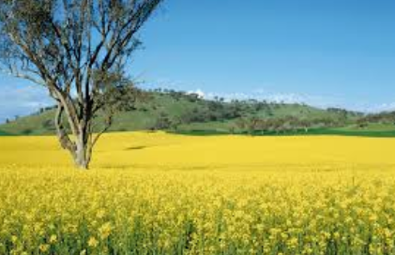
Question 1 (9 marks)
Canola crops like the one pictured below have
become a common sight around Victoria.
The oil extracted from the seeds of the crop
can be used in the transport industry or the
food industry.

Like most fats and oils, canola oil contains a
mixture of fatty acids, oleic acid being the most
common at 56%.

a. i. Draw the complete structure of a molecule of biodiesel that could be formed from the
reaction between oleic acid and ethanol. 2 marks

ii. Write a balanced equation for the complete combustion of the biodiesel molecule.
2 marks
________________________________________________________________________

b. i. What category of fatty acid does oleic acid belong to? _____________ 1 mark

ii. How will the melting point of oleic acid compare to that of stearic acid? Explain
your answer. 2 marks

_______________________________________________________________________

_______________________________________________________________________

c. There are limitations on the production of biodiesel from canola oil in Australia.
List two limitations. 2 marks

_______________________________________________________________________

_______________________________________________________________________
Question 2 (10 marks)
The zinc alkaline cell is a very common commercial battery with a voltage of 1.43 V. A cross-section of the cell is shown below.
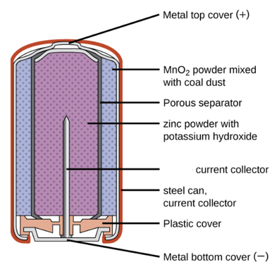
The overall equation for the reaction occurring is

Zn(s) + 2MnO₂(s) + H₂O(l) Mn₂O₃(s) + Zn(OH)₂(s)

a. Write balanced half-equations for the reaction occurring at the 2 marks

anode: ___________________________________________________________

cathode: ___________________________________________________________

b. Research shows the voltage of this zinc half-equation is listed as -1.28 V.
What will the voltage of the MnO₂ half-equation be? 1 mark

_______________________________________________________________________

c. One of the advantages of this cell over the cheaper zinc dry cell is that the casing of the
battery does not corrode away. Use the half-equations you have written to explain why
this is the case. 2 marks

_______________________________________________________________________

_______________________________________________________________________

d. Methane gas can be used to produce electrical energy in a fuel cell. Write half-equations
and an overall equation for the reactions of methane in an alkaline fuel cell. 3 marks

anode: _____________________________________________________________

cathode: _____________________________________________________________

overall: _____________________________________________________________

Question 3 (8 marks)
The amide molecule shown can be synthesised from smaller molecules in the process outlined below. Ethene is used as the starting reactant.

HCl H₃PO₄/H⁺

B

A

NH₃ H⁺/Cr₂O₇²⁻

D

C

a. Use the boxes provided to draw and name the molecules A to D. 4 marks

b. Write a balanced equation for – 2 marks
i. the reaction between ethene and HCl.
______________________________________________________________________

ii. the reaction between molecule A and NH₃.

_______________________________________________________________________

c. Write a balanced half-equation for the formation of molecule D. 1 mark

_____________________________________________________________________

d. Give an example of reaction in the above pathway that has an atom economy of 100%.
1 mark
_____________________________________________________________________
Question 4 (11 marks)
Sulfur trioxide is an unstable gas that can decompose according to the equation:

2SO₃(g) ⇌ 2SO₂(g) + O₂(g) ΔH > 0

a. A mixture of the thee gases is added to a gas syringe and the contents are allowed
sufficient time to reach equilibrium. The volume of the syringe is then halved and the
temperature is held constant. Explain
the impact of this volume change on

i. the value of the equilibrium constant. 1 mark

_______________________________________________________________________

ii. the concentration of SO₂ gas. 2 marks

________________________________________________________________________

________________________________________________________________________

iii. the amount of SO₂ gas. 1 mark

________________________________________________________________________

_________________________________________________________________________

b. A sample of sulfur trioxide gas is added to an empty reactor and its concentration is
measured over the next 3 minutes. The SO₃ concentration is plotted on the graph
below.
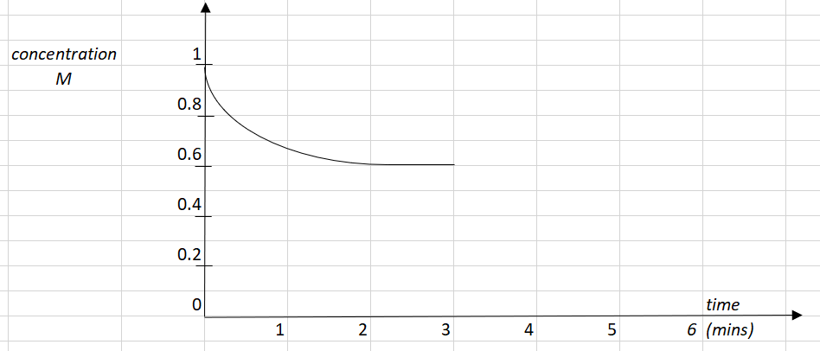

i. Draw on the graph provided the corresponding concentration for the sulfur dioxide
and oxygen gases during the first 3 minutes. 2 marks

ii. Calculate the equilibrium constant at the 3 minute mark. 2 marks

______________________________________________________________________

______________________________________________________________________

______________________________________________________________________
iii. At the 3 minute mark the temperature of the system is increased. Use the graph to
show the impact of this change on all 3 gases. 3 marks

Question 5 (9 marks)
The mass spectrum of an aldehyde molecule is shown below.
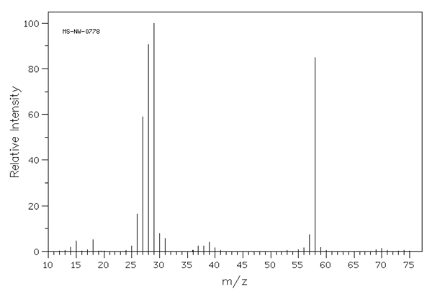
a. Use the mass spectrum to:

i. suggest a molecular formula for the molecule _____________________ 1 mark

ii. suggest a name for the molecule. ___________________________ 1 mark

b. Draw and name a molecule that could be used to manufacture this aldehyde. 2 marks

c. The infrared spectrum for the aldehyde molecule is shown below.
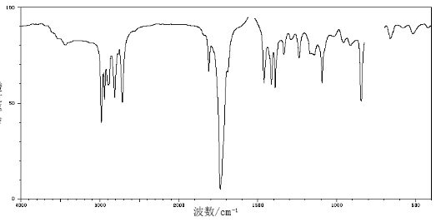

In the table below, write the bond responsible for the wave numbers given. 1 mark

Wave number (cm⁻¹) | Bond
3000
1750

d. The proton-NMR spectrum for the aldehyde molecule is shown below.

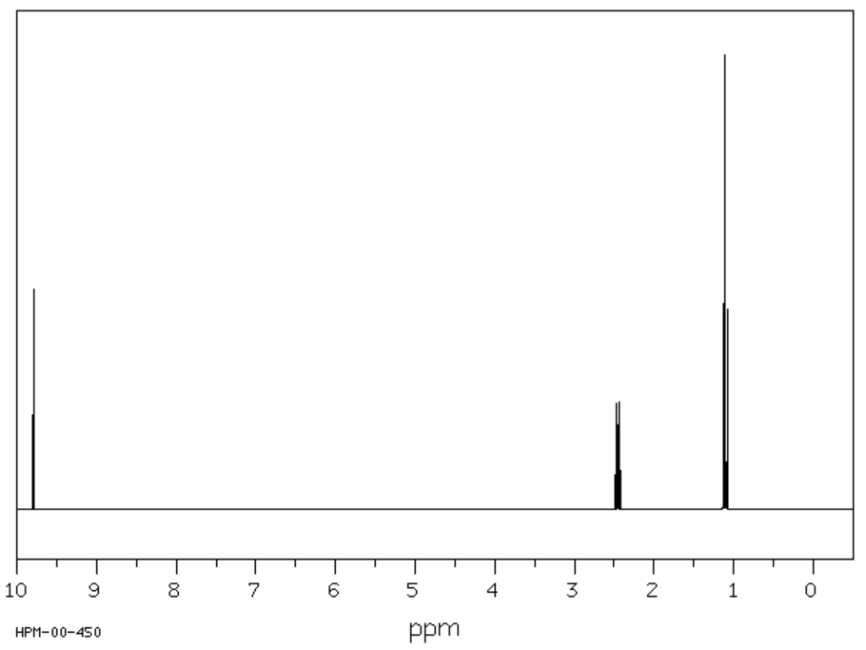
The splitting pattern is not obvious on this spectrum. In the table below, draw the part of the molecule responsible for each set of peaks and predict the likely splitting pattern. 3 marks

Shift | Likely structure | Splitting pattern
1.1

2.4

9.8

e. This molecule can be produced naturally from a reaction involving one of the food
groups. Suggest a reaction that might lead to the formation of this aldehyde. 1 mark

______________________________________________________________________

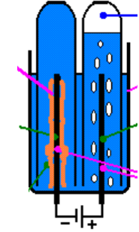
Question 6 (8 marks)
The diagram shown is a snippet from an electrolysis cell.
The products shown are a brown metal and a colourless gas.

1 mark
a. i. Suggest a solution that could be used to lead to these products.

_________________________________________________

ii. Use the template below to show the half-equations and
overall reaction occurring. 3 marks

anode: _____________________________________________

cathode: _____________________________________________

overall equation: _______________________________________

b. Calculate the volume of gas produced if a current of 6.60 amps runs for 2 mins 20 secs.
The temperature is 21.0 ⁰C and the pressure 95.0 kPa. 4 marks

______________________________________________________________________

______________________________________________________________________

______________________________________________________________________

______________________________________________________________________

Question 7 (10 marks)
Testing laboratories usually test the heat of combustion of food items in a bomb calorimeter
rather than a solution calorimeter. A diagram of a bomb calorimeter is shown below.
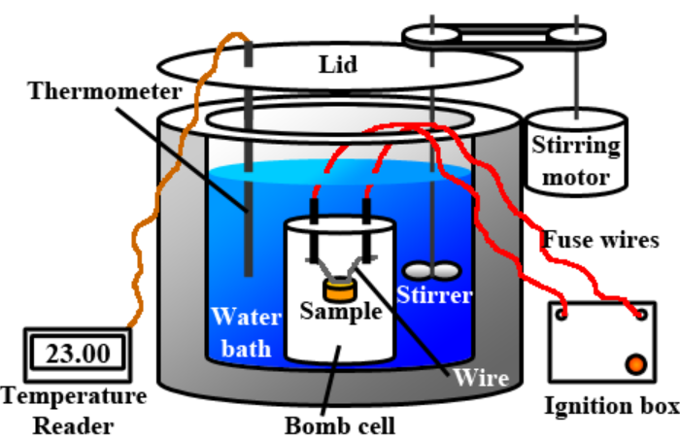

a. i. List two reasons why a bomb calorimeter might provide a more accurate value than
a solution calorimeter for the heat of combustion of a biscuit. 2 marks

_______________________________________________________________________

_______________________________________________________________________

_______________________________________________________________________

ii. Oxygen is often added to the bomb cell under pressure. Why is a high pressure used?
1 mark
_______________________________________________________________________

iii. What is the role of the ignition box in the above apparatus? 1 mark

_______________________________________________________________________

b. The following data is recorded by a student who is investigating the heat of combustion
of Anzac biscuits. 3 marks

calibration | experiment
Addition of 2460 J of energy  Initial temperature: 18.4⁰C  Final temperature: 22.9⁰C | initial temperature of water: 22.9⁰C  final temperature of water: 27.4⁰C  mass of biscuit: 0.962 g

Calculate the heat of combustion of the biscuit.

________________________________________________________________________

________________________________________________________________________

c. i. In a recipe change, the manufacturer of the biscuit lowers the fat content but increases
the sugar content. Explain the impact of this change on the heat of combustion of the
biscuit. 1 mark

_______________________________________________________________________

_______________________________________________________________________

ii. In a different recipe experiment the manufacturer replaces the 6 g of sugar in each
biscuit with 6 g of aspartame. Explain the impact of this change on the 2 marks

- energy content: __________________________________________________________

- taste: _________________________________________________________

Question 8 (7 marks)
a. If you sit a piece of white bread in your mouth you will notice a sweet taste emerge over
the next few minutes.

i. What reaction is occurring to produce this sweet taste? 1 mark

_______________________________________________________________________

ii. How does chewing your food thoroughly aid the digestion process? 1 mark

_______________________________________________________________________

b. A small percentage of the population take lactase tablets regularly. Explain, from a
chemistry point of view, why they might do this. 1 mark

c. Hydrogen peroxide is a clear liquid with a chemical formula of H₂O₂. It is used as an
antiseptic and as a bleach. It decomposes easily to form water and oxygem.
The rate of this reaction increases if a piece of liver is added to the hydrogen peroxide and
it is also increased if potassium iodide is added.
i. Explain how a piece of liver increases the rate of decomposition. 2 marks

_______________________________________________________________________

_______________________________________________________________________

ii. Identify one similarity and one difference in the action of KI compared to that of
liver. 2 marks

_______________________________________________________________________

_______________________________________________________________________

Question 9 (10 marks)
A student investigates the voltage values on the electrochemical series of various metals. Her experimental set-up and data collected is shown below.

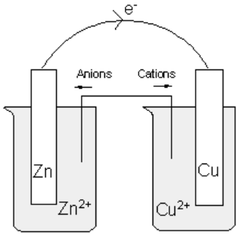

Hypothesis: That the voltage values shown on the electrochemical series can be replicated in a school laboratory.

Procedure
The student prepares a zinc metal, zinc solution half-cell and connects it in turn to four other half-cells.

Salt bridge: prepared from absorbent paper soaked in Na₂SO₄ solution.
Solutions: All carefully prepared 0.10 M solutions.
Temperature: 18.4 ⁰C

The voltages obtained and the polarity of each cell are recorded in the table below.
Cell combination | Positive electrode | Cell voltage (V)
Zn²⁺,Zn(s)||Cu²⁺,Cu(s) | copper | 0.82
Zn²⁺,Zn(s)||Pb²⁺,Pb(s) | lead | 0.54
Zn²⁺,Zn(s)||Mg²⁺,Mg(s) | zinc | 1.10
Zn²⁺,Zn(s)||Fe²⁺,Fe(s) | iron | 0.29

Student conclusion: The laboratory values for an electrochemical series are wrong as they are not consistent with those of the Data book .

a. For this experiment, identify the 2 marks

i. independent variable _________________________________________

ii. dependent variable _________________________________________

b. The zinc half-cell is represented in your data book as 3 marks

Zn²⁺(aq) + 2e ⇌ Zn(s)

The student assigns a value of 0.00 V to this half-equation.
Use the experimental data to add the half-equations for the other four metals tested to
make a simplified electrochemical series below.
Include the voltages obtained by experiment in your table.

Zn²⁺(aq) + 2e ⇌ Zn(s) 0.00 V

c. Comment on the validity of the student’s conclusion. 2 marks

___________________________________________________________________

___________________________________________________________________

___________________________________________________________________

d. List three reasons the voltages obtained by the student might not match those of the
electrochemical series in your Data Book. 3 marks

___________________________________________________________________

___________________________________________________________________

___________________________________________________________________

Question 10 (8 marks)
Proteins are natural polymers formed when many amino acids bond together. The chemical structure of proteins is complex and involves several levels.

a. Use the protein segment below to demonstrate your understanding of the structure of
proteins. In your answer: 5 marks
- explain the difference between primary, secondary and tertiary structure
- identify the types of bonding present.
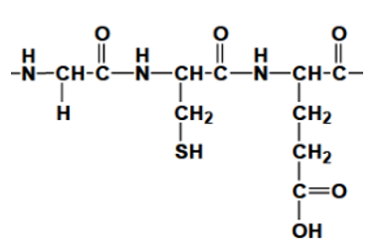

________________________________________________________________________

_________________________________________________________________________

________________________________________________________________________

_________________________________________________________________________

________________________________________________________________________

_________________________________________________________________________

________________________________________________________________________

_________________________________________________________________________
b. Proteins can be metabolised in the human body. Explain the likely steps in the digestion
of proteins and the likely uses of the body for the products of protein digestion. 3 marks

________________________________________________________________________

_________________________________________________________________________

________________________________________________________________________

_________________________________________________________________________

________________________________________________________________________

_________________________________________________________________________

END OF EXAM

